NAME:- P . MANJUNATH NAIDU

REG NO:- 192525431

TOPIC -3

Brute Force - Searching & String Matching
Sequential Search, Brute Force String Matching

Dr. R. Jeena

Sequential Search

Question 1
Write a program to implement Sequential Search to find a given element in an array. Input:
Array: 12, 25, 8, 45, 32, 19, 50
Key: 32 Output:
Element found at position 5 Number of comparisons = 5

Question 2
Implement Sequential Search for an unsuccessful search. Input:
Array: 5, 10, 15, 20, 25, 30, 35
Key: 18 Output:
Element not found
Number of comparisons = 7

Question 3
Write a program to find the first occurrence of an element using Sequential Search. Input:
Array: 10, 25, 15, 25, 30, 25, 40

Key: 25 Output:
First occurrence at position 2

Question 4
Implement Sequential Search to find all occurrences of a given element. Input:
Array: 7, 12, 7, 25, 18, 7, 30, 7
Key: 7 Output:
Occurrences at positions:
1, 3, 6, 8
Total occurrences = 4

Question 5
Write a program to count:
- Total comparisons
- Total matches
- Total mismatches during Sequential Search.
Input:
Array: 3, 6, 9, 12, 15, 18, 21
Key: 15

Question 6
Implement Sentinel Sequential Search and compare it with ordinary Sequential Search. Input:
Array: 14, 9, 22, 35, 18, 41, 27

Key: 18 Output:
Position found Comparison count

Question 7
Write a program to perform Sequential Search on an array of student register numbers. Input:
Register Numbers:
101, 102, 103, 104, 105, 106
Search Key: 104 Output:
Register Number found at position 4

Question 8
Implement Sequential Search for string data. Input:
Names:
Anu, Bala, Charan, Deepa, Esha, Farhan

Search Name:
Deepa Output:
Name found at position 4

Question 9
Write a program to perform Sequential Search on a 2-D matrix.

Input:
12 8 | 15
5 18 | 27
9 11 | 24

Key = 24 Output:
Element found at Row 3 Column 3

Question 10
Implement Sequential Search and analyze its performance. Input:
Array:
45, 23, 67, 12, 89, 34, 56, 78, 90, 11,
29, 73, 18, 64, 37

Search Keys:
73
18
100
Tasks:
- Show each comparison.
- Count comparisons for every search.
- Identify best, average, and worst cases.
- Determine:
  - Best-case complexity
  - Average-case complexity
  - Worst-case complexity
  - Space complexity

Brute Force String Matching

Question 1
Implement the Brute Force String Matching Algorithm to search for a pattern in a given text. Input:
- Text = "AABAACAADAABAABA"
- Pattern = "AABA" Output:
- Position(s) where the pattern occurs.
- Total number of comparisons.

Question 2
Write a program to find all occurrences of a pattern in a text using Brute Force String Matching. Input:
- Text = "BANANABANANA"
- Pattern = "ANA" Output:
- Occurrences at positions 1, 3, 7, 9.

Question 3
Implement Brute Force String Matching and display the comparison table for each alignment.

Input:
- Text = "MISSISSIPPI"
- Pattern = "ISSI" Output:
- Shift number
- Comparisons made
- Match/Mismatch result

Question 4
Write a program to count:
- Total character comparisons
- Total matches
- Total mismatches
during Brute Force String Matching. Input:
- Text = "ABABABABAB"
- Pattern = "ABAB"

Question 5
Implement Brute Force String Matching and determine whether the search is:
- Best Case
- Average Case
- Worst Case Input:
- Text = "AAAAAAAAAB"
- Pattern = "AAAAB"
Display the number of comparisons performed.

Question 6
Write a program that searches for a pattern in a text and reports the first occurrence only using Brute Force String Matching.
Input:

- Text = "COMPUTERSCIENCE"
- Pattern = "SCI" Output:
- First occurrence position
- Number of comparisons

Question 7
Implement Brute Force String Matching for case-insensitive searching. Input:
- Text = "DataStructuresAndAlgorithms"
- Pattern = "ALGORITHMS" Output:
- Pattern found position

Question 8
Write a program to compare the execution of Brute Force String Matching for:
- Successful search
- Unsuccessful search Input:
  - Text = "PROGRAMMINGLAB"
  - Pattern 1 = "LAB"
  - Pattern 2 = "TEST"
Display the comparison count for both cases.

Question 9
Implement Brute Force String Matching and display every alignment of the pattern with the text. Input:
  - Text = "ABCDABCABCDA"
  - Pattern = "ABCDA" Output:
  - Alignment number
  - Matching result

  - Pattern occurrence positions

Question 10
Write a complete program for Brute Force String Matching and perform complexity analysis. Input:
  - Text = "TTATAGATCTCGTATTCTTTATAGATCTCCTATTCTT"
  - Pattern = "TATCTT" Tasks:
- Find all occurrences of the pattern.
- Count total comparisons.
- Display the shifting process.
- Analyze:
  - Best-case complexity
  - Worst-case complexity
  - Space complexity

ANSWERS
Question 1 — Sequential Search
C CODE

#include <stdio.h>

int main() {
int a[] = {12, 25, 8, 45, 32, 19, 50};
int n = 7, key = 32;
int i, comparisons = 0;

for (i = 0; i < n; i++) {
comparisons++;

if (a[i] == key) {
printf("Element found at position %d\n", i + 1);
printf("Number of comparisons = %d\n", comparisons);
return 0;
}
}

printf("Element not found\n");
printf("Number of comparisons = %d\n", comparisons);

return 0;
}

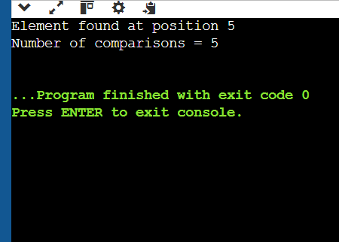

Question 2 — Unsuccessful Sequential Search

#include <stdio.h>

int main() {
int a[] = {5, 10, 15, 20, 25, 30, 35};
int n = 7, key = 18;
int i, comparisons = 0;

for (i = 0; i < n; i++) {
comparisons++;

if (a[i] == key) {
printf("Element found at position %d\n", i + 1);
printf("Number of comparisons = %d\n", comparisons);
return 0;
}
}

printf("Element not found\n");
printf("Number of comparisons = %d\n", comparisons);

return 0;
}

OUT PUT:-
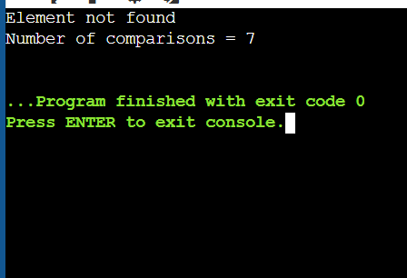

Question 3 — First Occurrence

#include <stdio.h>

int main() {
int a[] = {10, 25, 15, 25, 30, 25, 40};
int n = 7, key = 25;
int i;

for (i = 0; i < n; i++) {
if (a[i] == key) {
printf("First occurrence at position %d\n", i + 1);
return 0;
}
}

printf("Element not found\n");

return 0;
}

OUT PUT:-

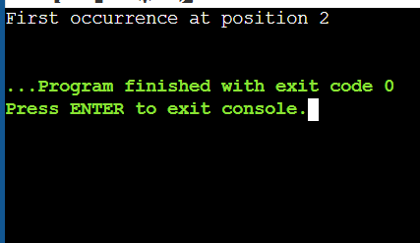

Question 4 — Find All Occurrences

#include <stdio.h>

int main() {
int a[] = {7, 12, 7, 25, 18, 7, 30, 7};
int n = 8, key = 7;
int i, count = 0;

printf("Occurrences at positions:\n");

for (i = 0; i < n; i++) {
if (a[i] == key) {
printf("%d ", i + 1);
count++;
}
}

printf("\nTotal occurrences = %d\n", count);

return 0;
}

OUT PUT:-

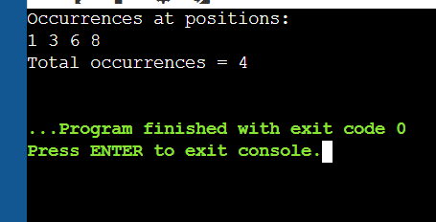

Question 5 — Comparisons, Matches and Mismatches

#include <stdio.h>

int main() {
int a[] = {3, 6, 9, 12, 15, 18, 21};
int n = 7, key = 15;
int i;
int comparisons = 0, matches = 0, mismatches = 0;

for (i = 0; i < n; i++) {
comparisons++;

if (a[i] == key) {
matches++;
break;
} else {
mismatches++;
}
}

printf("Total comparisons = %d\n", comparisons);
printf("Total matches = %d\n", matches);
printf("Total mismatches = %d\n", mismatches);

return 0;
}

OUT PUT:-

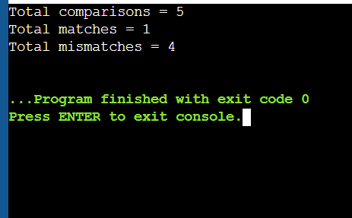

Question 6 — Sentinel Sequential Search

#include <stdio.h>

int main() {
int a[] = {14, 9, 22, 35, 18, 41, 27};
int n = 7, key = 18;
int last, i, comparisons = 0;

last = a[n - 1];
a[n - 1] = key;

i = 0;

while (a[i] != key) {
i++;
comparisons++;
}

comparisons++;

a[n - 1] = last;

if (i < n - 1 || a[n - 1] == key) {
printf("Position found: %d\n", i + 1);
} else {
printf("Element not found\n");
}

printf("Comparison count = %d\n", comparisons);

return 0;
}

OUTPUT:-

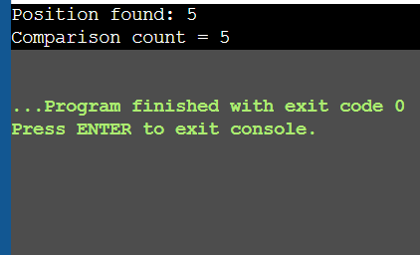

Question 7 — Student Register Numbers

#include <stdio.h>

int main() {
int reg[] = {101, 102, 103, 104, 105, 106};
int n = 6, key = 104;
int i;

for (i = 0; i < n; i++) {
if (reg[i] == key) {
printf("Register Number found at position %d\n", i + 1);
return 0;
}
}

printf("Register Number not found\n");

return 0;
}

OUTPUT:-
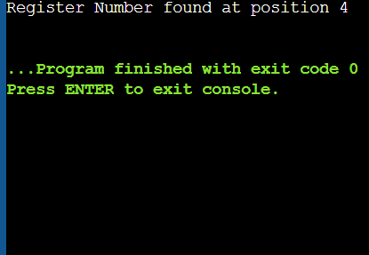
Question 8 — Sequential Search for Strings

#include <stdio.h>
#include <string.h>

int main() {
char names[][20] = {
"Anu", "Bala", "Charan",
"Deepa", "Esha", "Farhan"
};

char key[] = "Deepa";
int n = 6;
int i;

for (i = 0; i < n; i++) {
if (strcmp(names[i], key) == 0) {
printf("Name found at position %d\n", i + 1);
return 0;
}
}

printf("Name not found\n");

return 0;
}

OUTPUT:-
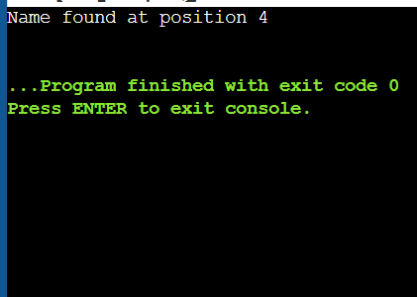

Question 9 — Sequential Search in 2-D Matrix

#include <stdio.h>

int main() {
int a[3][3] = {
{12, 8, 15},
{5, 18, 27},
{9, 11, 24}
};

int key = 24;
int i, j;

for (i = 0; i < 3; i++) {
for (j = 0; j < 3; j++) {

if (a[i][j] == key) {
printf("Element found at Row %d Column %d\n",
i + 1, j + 1);
return 0;
}
}
}

printf("Element not found\n");

return 0;
}

OUT PUT:-
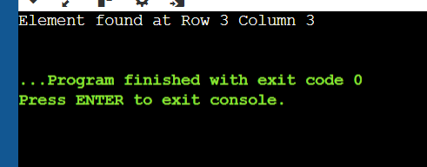

Question 10 — Sequential Search Performance

#include <stdio.h>

int sequentialSearch(int a[], int n, int key) {
int i, comparisons = 0;

for (i = 0; i < n; i++) {
comparisons++;

printf("Compare %d with %d\n", a[i], key);

if (a[i] == key) {
printf("Found at position %d\n", i + 1);
printf("Comparisons = %d\n", comparisons);
return comparisons;
}
}

printf("Not found\n");
printf("Comparisons = %d\n", comparisons);

return comparisons;
}

int main() {
int a[] = {
45, 23, 67, 12, 89,
34, 56, 78, 90, 11,
29, 73, 18, 64, 37
};

int n = 15;

printf("SEARCH FOR 73\n");
sequentialSearch(a, n, 73);

printf("\nSEARCH FOR 18\n");
sequentialSearch(a, n, 18);

printf("\nSEARCH FOR 100\n");
sequentialSearch(a, n, 100);

printf("\nComplexity Analysis:\n");
printf("Best Case : O(1)\n");
printf("Average Case : O(n)\n");
printf("Worst Case : O(n)\n");
printf("Space : O(1)\n");

return 0;
}

OUTPUT:-
SEARCH FOR 73
Compare 45 with 73
Compare 23 with 73
Compare 67 with 73
Compare 12 with 73
Compare 89 with 73
Compare 34 with 73
Compare 56 with 73
Compare 78 with 73
Compare 90 with 73
Compare 11 with 73
Compare 29 with 73
Compare 73 with 73
Found at position 12
Comparisons = 12

SEARCH FOR 18
Compare 45 with 18
Compare 23 with 18
Compare 67 with 18
Compare 12 with 18
Compare 89 with 18
Compare 34 with 18
Compare 56 with 18
Compare 78 with 18
Compare 90 with 18
Compare 11 with 18
Compare 29 with 18
Compare 73 with 18
Compare 18 with 18
Found at position 13
Comparisons = 13

SEARCH FOR 100
Compare 45 with 100
Compare 23 with 100
Compare 67 with 100
Compare 12 with 100
Compare 89 with 100
Compare 34 with 100
Compare 56 with 100
Compare 78 with 100
Compare 90 with 100
Compare 11 with 100
Compare 29 with 100
Compare 73 with 100
Compare 18 with 100
Compare 64 with 100
Compare 37 with 100
Not found
Comparisons = 15

Complexity Analysis:
Best Case : O(1)
Average Case : O(n)
Worst Case : O(n)
Space : O(1)

PART B — BRUTE FORCE STRING MATCHING
Question 1 — Search Pattern in Text

#include <stdio.h>
#include <string.h>

int main() {
char text[] = "AABAACAADAABAABA";
char pattern[] = "AABA";

int n = strlen(text);
int m = strlen(pattern);
int i, j, comparisons = 0;

printf("Pattern occurs at positions: ");

for (i = 0; i <= n - m; i++) {
for (j = 0; j < m; j++) {
comparisons++;

if (text[i + j] != pattern[j])
break;
}

if (j == m)
printf("%d ", i);
}

printf("\nTotal comparisons = %d\n", comparisons);

return 0;
}

OUTPUT:-
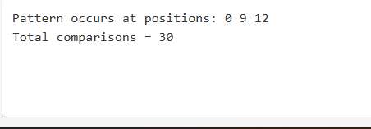

Question 2 — Find All Occurrences

#include <stdio.h>
#include <string.h>

int main() {
char text[] = "BANANABANANA";
char pattern[] = "ANA";

int n = strlen(text);
int m = strlen(pattern);
int i, j;

printf("Occurrences at positions: ");

for (i = 0; i <= n - m; i++) {
for (j = 0; j < m; j++) {
if (text[i + j] != pattern[j])
break;
}

if (j == m)
printf("%d ", i);
}

return 0;
}

OUTPUT:-

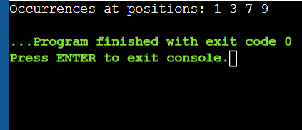

Question 3 — Comparison Table

#include <stdio.h>
#include <string.h>

int main() {
char text[] = "MISSISSIPPI";
char pattern[] = "ISSI";

int n = strlen(text);
int m = strlen(pattern);

int i, j, comparisons;

for (i = 0; i <= n - m; i++) {

comparisons = 0;

for (j = 0; j < m; j++) {
comparisons++;

if (text[i + j] != pattern[j])
break;
}

printf("Shift %d: Comparisons = %d, ", i, comparisons);

if (j == m)
printf("Match\n");
else
printf("Mismatch\n");
}

return 0;
}

OUTPUT:-
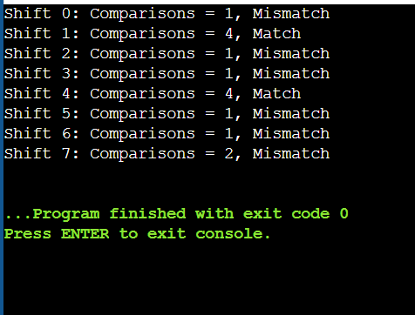

Question 4 — Character Comparisons, Matches, Mismatches

#include <stdio.h>
#include <string.h>

int main() {
char text[] = "ABABABABAB";
char pattern[] = "ABAB";

int n = strlen(text);
int m = strlen(pattern);

int i, j;
int comparisons = 0;
int matches = 0;
int mismatches = 0;

for (i = 0; i <= n - m; i++) {

for (j = 0; j < m; j++) {

comparisons++;

if (text[i + j] == pattern[j]) {
matches++;
} else {
mismatches++;
break;
}
}
}

printf("Total character comparisons = %d\n", comparisons);
printf("Total matches = %d\n", matches);
printf("Total mismatches = %d\n", mismatches);

return 0;
}

OUTPUT:-
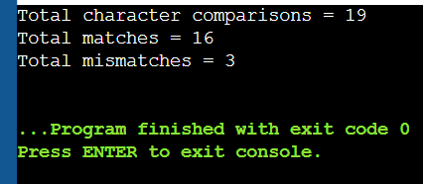

Question 5 — Best, Average or Worst Case
#include <stdio.h>
#include <string.h>

int main() {
char text[] = "AAAAAAAAAB";
char pattern[] = "AAAAB";

int n = strlen(text);
int m = strlen(pattern);

int i, j, comparisons = 0;

for (i = 0; i <= n - m; i++) {

for (j = 0; j < m; j++) {
comparisons++;

if (text[i + j] != pattern[j])
break;
}

if (j == m) {
printf("Pattern found at position %d\n", i);
break;
}
}

printf("Number of comparisons = %d\n", comparisons);

printf("\nThis is a worst-case type example.\n");
printf("Best Case = O(n)\n");
printf("Worst Case = O(n*m)\n");

return 0;
}

OUTPUT:-
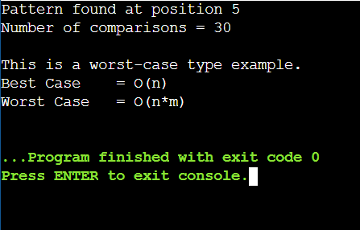

Question 6 — First Occurrence Only

#include <stdio.h>
#include <string.h>

int main() {
char text[] = "COMPUTERSCIENCE";
char pattern[] = "SCI";

int n = strlen(text);
int m = strlen(pattern);

int i, j;
int comparisons = 0;

for (i = 0; i <= n - m; i++) {

for (j = 0; j < m; j++) {
comparisons++;

if (text[i + j] != pattern[j])
break;
}

if (j == m) {
printf("First occurrence position = %d\n", i);
printf("Number of comparisons = %d\n", comparisons);
return 0;
}
}

printf("Pattern not found\n");
printf("Number of comparisons = %d\n", comparisons);

return 0;
}

OUTPUT:-
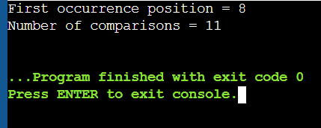

Question 7 — Case-Insensitive Searching

#include <stdio.h>
#include <string.h>
#include <ctype.h>

int main() {
char text[] = "DataStructuresAndAlgorithms";
char pattern[] = "ALGORITHMS";

int n = strlen(text);
int m = strlen(pattern);

int i, j;

for (i = 0; i <= n - m; i++) {

for (j = 0; j < m; j++) {

if (tolower(text[i + j]) != tolower(pattern[j]))
break;
}

if (j == m) {
printf("Pattern found at position %d\n", i);
return 0;
}
}

printf("Pattern not found\n");

return 0;
}

OUTPUT:-
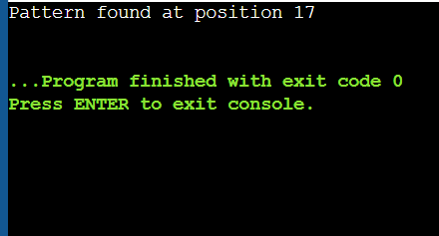

Question 8 — Successful vs Unsuccessful Search

#include <stdio.h>
#include <string.h>

int bruteForce(char text[], char pattern[]) {

int n = strlen(text);
int m = strlen(pattern);

int i, j;
int comparisons = 0;

for (i = 0; i <= n - m; i++) {

for (j = 0; j < m; j++) {
comparisons++;

if (text[i + j] != pattern[j])
break;
}

if (j == m) {
printf("Pattern \"%s\" found\n", pattern);
printf("Comparisons = %d\n", comparisons);
return comparisons;
}
}

printf("Pattern \"%s\" not found\n", pattern);
printf("Comparisons = %d\n", comparisons);

return comparisons;
}

int main() {

char text[] = "PROGRAMMINGLAB";

printf("Successful Search:\n");
bruteForce(text, "LAB");

printf("\nUnsuccessful Search:\n");
bruteForce(text, "TEST");

return 0;
}

OUTPUT:-
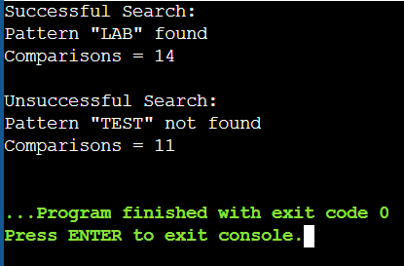

Question 9 — Display Every Alignment

#include <stdio.h>
#include <string.h>

int main() {
char text[] = "ABCDABCABCDA";
char pattern[] = "ABCDA";

int n = strlen(text);
int m = strlen(pattern);

int i, j, found;

for (i = 0; i <= n - m; i++) {

printf("Alignment %d: ", i + 1);

for (j = 0; j < i; j++)
printf(" ");

printf("%s\n", pattern);

found = 1;

for (j = 0; j < m; j++) {
if (text[i + j] != pattern[j]) {
found = 0;
break;
}
}

if (found)
printf("Result: Match at position %d\n\n", i);
else
printf("Result: Mismatch\n\n");
}

return 0;
}

OUTPUT:-
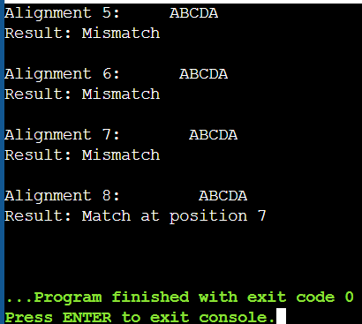

Question 10 — Complete Brute Force + Complexity

#include <stdio.h>
#include <string.h>

int main() {

char text[] = "TTATAGATCTCGTATTCTTTATAGATCTCCTATTCTT";
char pattern[] = "TATCTT";

int n = strlen(text);
int m = strlen(pattern);

int i, j;
int comparisons = 0;
int found = 0;

printf("Text : %s\n", text);
printf("Pattern : %s\n\n", pattern);

printf("Shifting Process:\n");

for (i = 0; i <= n - m; i++) {

printf("Shift %d: ", i);

for (j = 0; j < m; j++) {

comparisons++;

if (text[i + j] != pattern[j]) {
printf("Mismatch\n");
break;
}
}

if (j == m) {
printf("Match\n");
printf("Pattern occurrence at position %d\n", i);
found = 1;
}
}

if (!found)
printf("Pattern not found\n");

printf("\nTotal comparisons = %d\n", comparisons);

printf("\nComplexity Analysis:\n");
printf("Best Case : O(n)\n");
printf("Worst Case : O(n*m)\n");
printf("Space : O(1)\n");

return 0;
}

OUTPUT:-

